**Plant Developmental Biology**

**Prof. Shri Ram Yadav**

**Department of Biotechnology**

**Indian Institute of Technology, Roorkee**

**Lecture - 03**

**Characteristics of Plant Growth and Development - II**

Welcome to the second lecture of Characteristic of Plant Growth and Development. So, if we recall in the first lecture, we had discussed the primary growth and development, secondary growth and development and lastly the lateral growth and development. We had also discussed about the axis where the growth and development occurs, the points or the region of the plants where the meristematic activities are positioned and how they are maintained and coordinated during the process of plant growth and development.

(Refer Slide Time: 01:05)

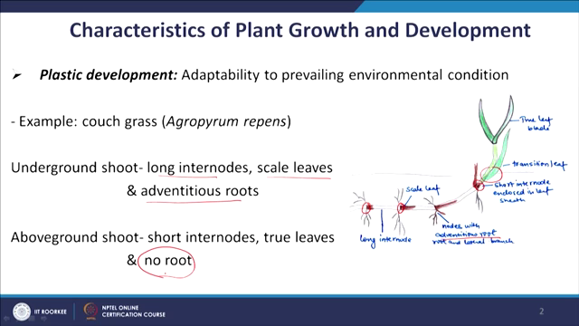

Now we will continue this lecture of characteristic of plant growth and development with another characteristic of plant development which is Plasticity. It is extremely important for the plants; considering the fact that plants are sessile in nature. They cannot move from one place to another place which means that they have to face all the environmental disturbance or all the environmental conditions just by standing at one place. And, to cope with this change in the environment, they have adopted a very nice mechanism which is a plastic in nature.

Thus the plasticity is basically an adaptability to prevailing environmental condition. I will take couple of examples for it and you will appreciate that how developmental plasticity is adopted or it is acquired by the plants.

If you take this example, this is couch grass. Basically, it’s shoot grows below the ground as well as above the ground. And, what happens when the shoots are growing underground. Underground means it has a very different environmental condition than the above ground. In underground, the light intensity is less. Oxygen availability and other factors are very different than the above ground.

You can see that when the shoot is growing underground, it has a developmental program which is giving rise to long internode and leaf like structure which is called scale leaf and more importantly every node you can see a lot of adventitious root development.

So, there is a developmental growth which is already going on here. But once this growing shoot reaches the ground and once it is coming outside the ground, it switches its developmental program. There is a change. The first thing that happens is now it would start making short internode.

So, the internode length is reduced to do that it has to change. It is the basic program of developmental biology. Another thing which happens there, is a formation of true leaf blade like structure. This shoot at the node is no longer making the roots. So, what are the changes it has to do developmentally?

It has changed its program for making long internode to the short internode. It has major changes in their program of the leaf development. Now, the leaf is different and more when it was underground it was having active developmental program for adventitious root development. But once it is coming above ground, it has to shut down the program of adventitious root development.